**OUTPUT AIRLINES**

**Summary statistics of airline data set**

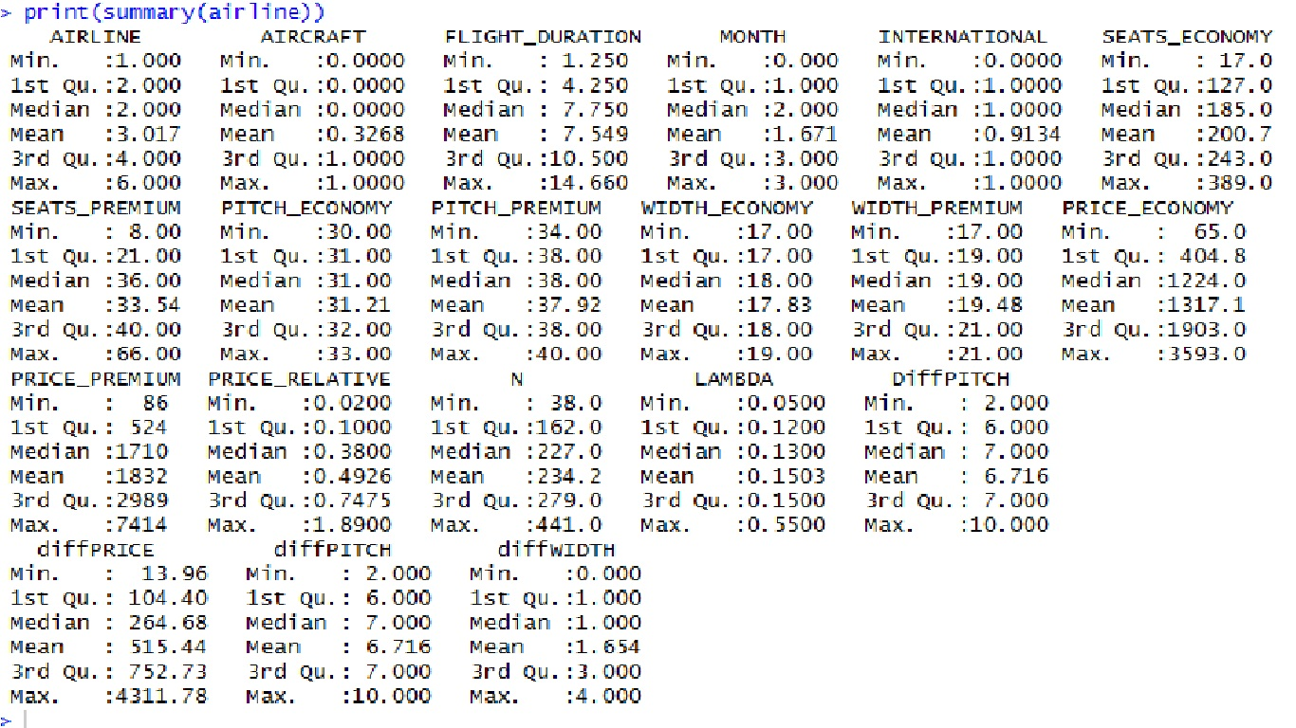

**Boxplot of diffPRICE and diffPITCH**

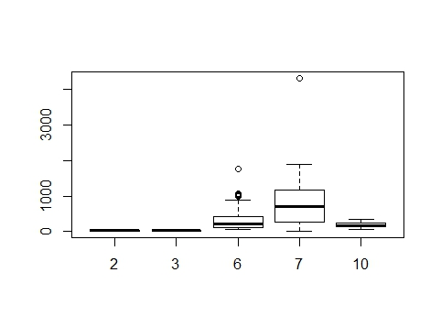

**Scatterplot of PRICE_PREMIUM and PRICE_ECONOMY**

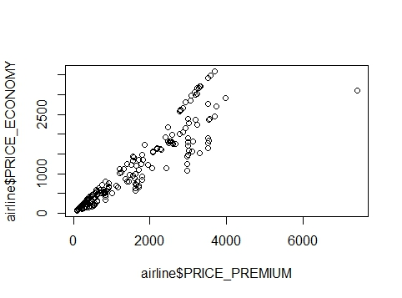

**Corrgram of airline intercorrelation**

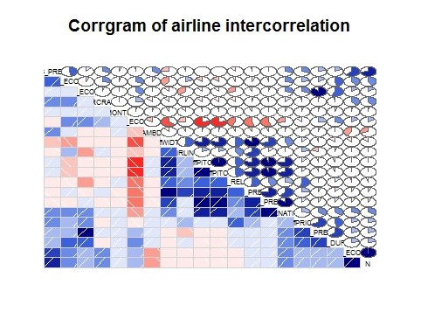

**Correlation matrix of airline**

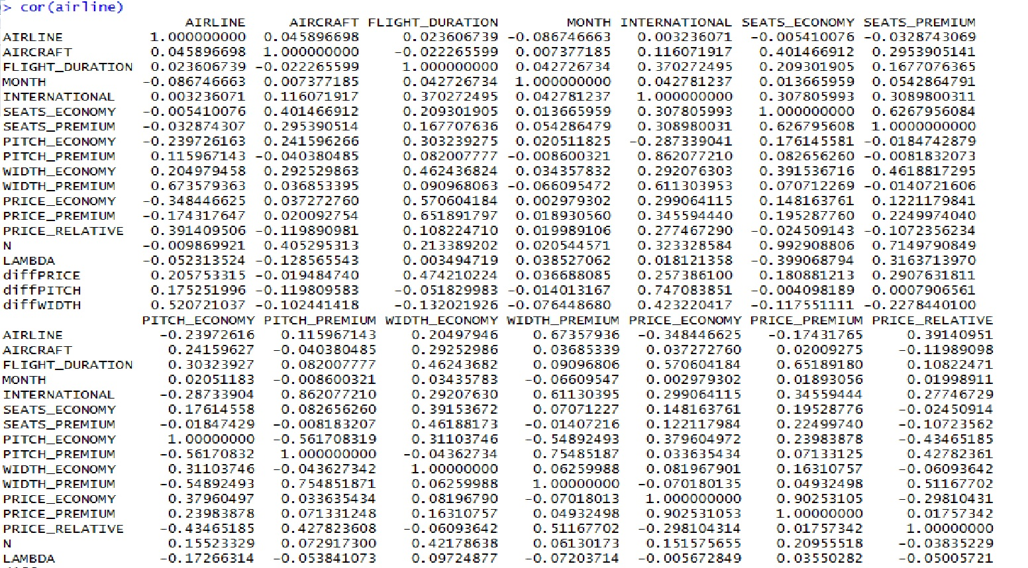

**T test between diffPITCH and diffWIDTH**

t.test(airline$diffPITCH, airline$diffWIDTH)

Welch Two Sample t-test

data: airline$diffPITCH and airline$diffWIDTH

t = 50.62, df = 809.74, p-value < 2.2e-16

alternative hypothesis: true difference in means is not equal to 0

95 percent confidence interval:

4.866452 5.259089

sample estimates:

mean of x mean of y

6.71645 1.65368

**Regression model Final ( outcome varible- diffPRICE )**

Call:

lm(formula = diffPRICE ~ FLIGHT_DURATION + INTERNATIONAL + diffWIDTH +

diffPITCH + LAMBDA, data = airline)

Residuals:

Min 1Q Median 3Q Max

-839.7 -281.4 -58.1 128.9 3370.9

Coefficients:

Estimate Std. Error t value Pr(>|t|)

(Intercept) -412.772 131.378 -3.142 0.00179 **

FLIGHT_DURATION 83.461 8.435 9.894 < 2e-16 ***

INTERNATIONAL -52.195 169.117 -0.309 0.75774

diffWIDTH 85.262 33.388 2.554 0.01098 *

diffPITCH 7.889 33.803 0.233 0.81556

LAMBDA 1010.042 391.517 2.580 0.01020 *

---

Signif. codes: 0 ‘***’ 0.001 ‘**’ 0.01 ‘*’ 0.05 ‘.’ 0.1 ‘ ’ 1

Residual standard error: 501.6 on 456 degrees of freedom

Multiple R-squared: 0.2651, Adjusted R-squared: 0.257

F-statistic: 32.9 on 5 and 456 DF, p-value: < 2.2e-16

**Regression model Final ( outcome varible- diffPRICE )**

**removing explanatory variables whose beta-coefficients are not statistically significant**

summary(model2A)

Call:

lm(formula = diffPRICE ~ FLIGHT_DURATION + diffWIDTH + LAMBDA,

data = airline)

Residuals:

Min 1Q Median 3Q Max

-836.2 -288.1 -53.6 129.9 3381.1

Coefficients:

Estimate Std. Error t value Pr(>|t|)

(Intercept) -402.025 91.405 -4.398 1.36e-05 ***

FLIGHT_DURATION 81.863 6.644 12.322 < 2e-16 ***

diffWIDTH 88.490 19.652 4.503 8.52e-06 ***

LAMBDA 1018.636 383.537 2.656 0.00819 **

---

Signif. codes: 0 ‘***’ 0.001 ‘**’ 0.01 ‘*’ 0.05 ‘.’ 0.1 ‘ ’ 1

Residual standard error: 500.5 on 458 degrees of freedom

Multiple R-squared: 0.2649, Adjusted R-squared: 0.2601

F-statistic: 55.03 on 3 and 458 DF, p-value: < 2.2e-16

**Anova table of previous two models**

Analysis of Variance Table

Model 1: diffPRICE ~ FLIGHT_DURATION + INTERNATIONAL + diffWIDTH + diffPITCH +

LAMBDA

Model 2: diffPRICE ~ FLIGHT_DURATION + diffWIDTH + LAMBDA

Res.Df RSS Df Sum of Sq F Pr(>F)

1 456 114725203

2 458 114749225 -2 -24023 0.0477 0.9534

**Residual versus fitted model plot (without removing any variable)**

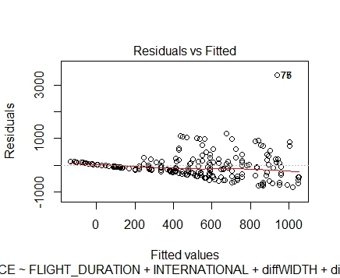

**95 % confidence intervals of fitted variables**

confint(model2) 2.5 % 97.5 %

(Intercept) -670.95222 -154.59086

FLIGHT_DURATION 66.88351 100.03806

INTERNATIONAL -384.54057 280.14977

diffWIDTH 19.64805 150.87557

diffPITCH -58.53973 74.31853

LAMBDA 240.64172 1779.44319

confint(model2A) 2.5 % 97.5 %

(Intercept) -581.65035 -222.39938

FLIGHT_DURATION 68.80652 94.91877

diffWIDTH 49.87066 127.10902

LAMBDA 264.92561 1772.34685